LPG GAS LEAKAGE MONITORING AND ALERT SYSTEM USING ARDUINO

Team leader – DHARANI .P

Team member - THAMBURAI.K

Team member - PRABAKARAN.P

Team member – ANBARASAN M

|  |  |  |
| --- | --- | --- |
| DHARANI P | 721919106023 | Dharani19@dsce.ac.in |
| THAMBURANI K | 721919106079 | thamburani19@dsce.ac.in |
| PRABAKARAN P | 721919106055 | prabakaran19@dsce.ac.in |
| ANBARASAN M | 721919106008 | Anbarasan19@dsce.ac.in |

**Project Report Format**

1.INTRODUCTION

1.1 Project Overview

1.2 Purpose

2. LITERATURE SURVEY

2.1 Existing problem

2.2 References

2.3 Problem Statement Definition

3. IDEATION & PROPOSED SOLUTION

3.1Empathy Map Canvas

3.2 Ideation & Brainstorming

3.3 Proposed Solution

3.4 Problem Solution fit

4. REQUIREMENT ANALYSIS

4.1 Functional requirement

4.2 Non-Functional requirements

5. PROJECT DESIGN

5.1 Data Flow Diagrams

5.2 Solution & Technical Architecture

5.3 User Stories

6. PROJECT PLANNING & SCHEDULING

6.1 Sprint Planning & Estimation

6.2 Sprint Delivery Schedule

6.3 Reports from JIRA

7. CODING & SOLUTIONING (Explain the features added in the project along with code)

7.1 Feature 1

7.2 Feature 2

7.3 Database Schema (if Applicable)

8. TESTING

8.1 Test Cases

8.2 User Acceptance Testing

9. RESULTS

9.1 Performance Metrics

10. ADVANTAGES & DISADVANTAGES

11. CONCLUSION

12. FUTURE SCOPE

13. APPENDIX

Source Code

GitHub & Project Demo Link

**1.INTRODUCTION**

Gas leaks have been increased from 0.72% of all kitchen accidents to 10.74% of all the kitchen accidents The small LPG cylinder of weight 5kg in which the burner is located immediately over the cylinder without using a rubber tube is seen to be safer than the one which uses a rubber pipe as this subway has the hazards of getting cracked which in turn can make way to leakage. A computer program to run online to detect the leakage locations has been originated and it functions as the automatic supervisor of the pipelines in remote areas Simple Gas leak detector is a simple device which is used to detect the leakage of gas and if the gas leak occurs, an equivalent message is conveyed by the means of an LCD screen and a buzzer and with the help of the GSM Module it is capable to broadcast messages to the stakeholders About the LPG leak. This device is at its initial level of development and with Modification in future this device will also trip off the mains Supply to ensure better safety and surety. The gas leak detector can find application not only at residential homes but Also it is applicable to hotels, restaurants and even in industries Where LPG gas is used for some or the other purposes .A computer program to run online to detect the leakage locations has been originated and it functions as the automatic supervisor of the pipelines in remote areas.

**1.1Project overview**

The system we have implemented is as follows – a microcontroller to control the working of the entire system. Alreadily available gas detection sensor to perform the sensing. A modem to send messages to the user of the leak status and an LCD display on the unit to display current status if the user should seek it.we have an Arduino Uno microcontroller connected to an MQ5 gas sensor. The gas sensor uses a tin dioxide filament whose resistance decreases with increase in the concentration of LPG. We have a SIM900A GSM Modem that is connected to the serial communication ports of the Arduino. It is a UART modem. There is also a LCD display hooked up to the Arduino that displays current status information. The microcontroller was programmed a using laptop and the executable was burned on to the ROM of the microcontroller. The system is designed to work in standalone mode and can automatically reset itself.

**1.2 Purpose**

the design of a sensor-based automatic gasleakage detector with an alert andcontrol system has been proposed.This is an affordable, less poer using,lightweight, portable,safe, user friendly, efficient, multi featured and simple system device for detecting gas. Gas leakage detection will not only provide us with significance in the health department but it will also lead to raise our economy,because when gas leaks it not only contaminates the atmosphere, but also wastage of gases will hurt our economy. The need for ensuring safety in workplaces is expected to be the key driving force for the market over the coming years.

**2 LITERATURE SURVEY**

 PATENT NUMBER: US5261268A

 FILE: GAS LEAK DETECTION SYSTEM

 INVENTOR: Mitsuo Namba

**APPLICATIONS:**

It comprises a flow sensor for detecting the amount of gas flowing through a gas flow passage, a pressure sensor, a pressure signal generator connected with the flow signal generator and the pressure signal generator.

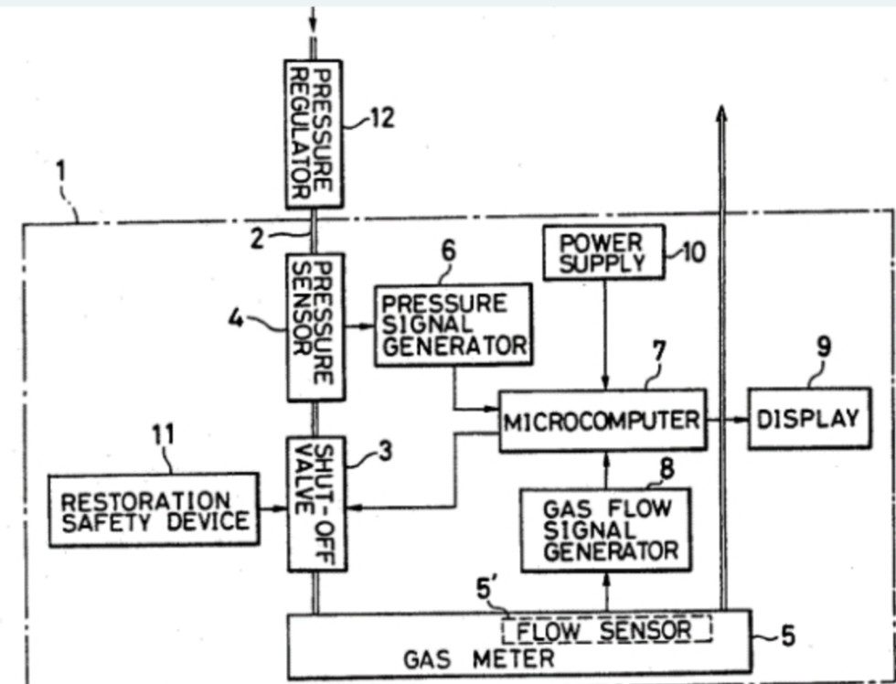

 FILE: GAS LEAK DETECTION SYSTEM

 INVENTOR: Jack L. Evans

**APPLICATIONS:**

A system for sensing the presence of a leak in a closed gas network interconnecting a gas source with a plurality of gas consuming appliances including thermostatic controls for automatically signalling demand to supply the selected appliances.

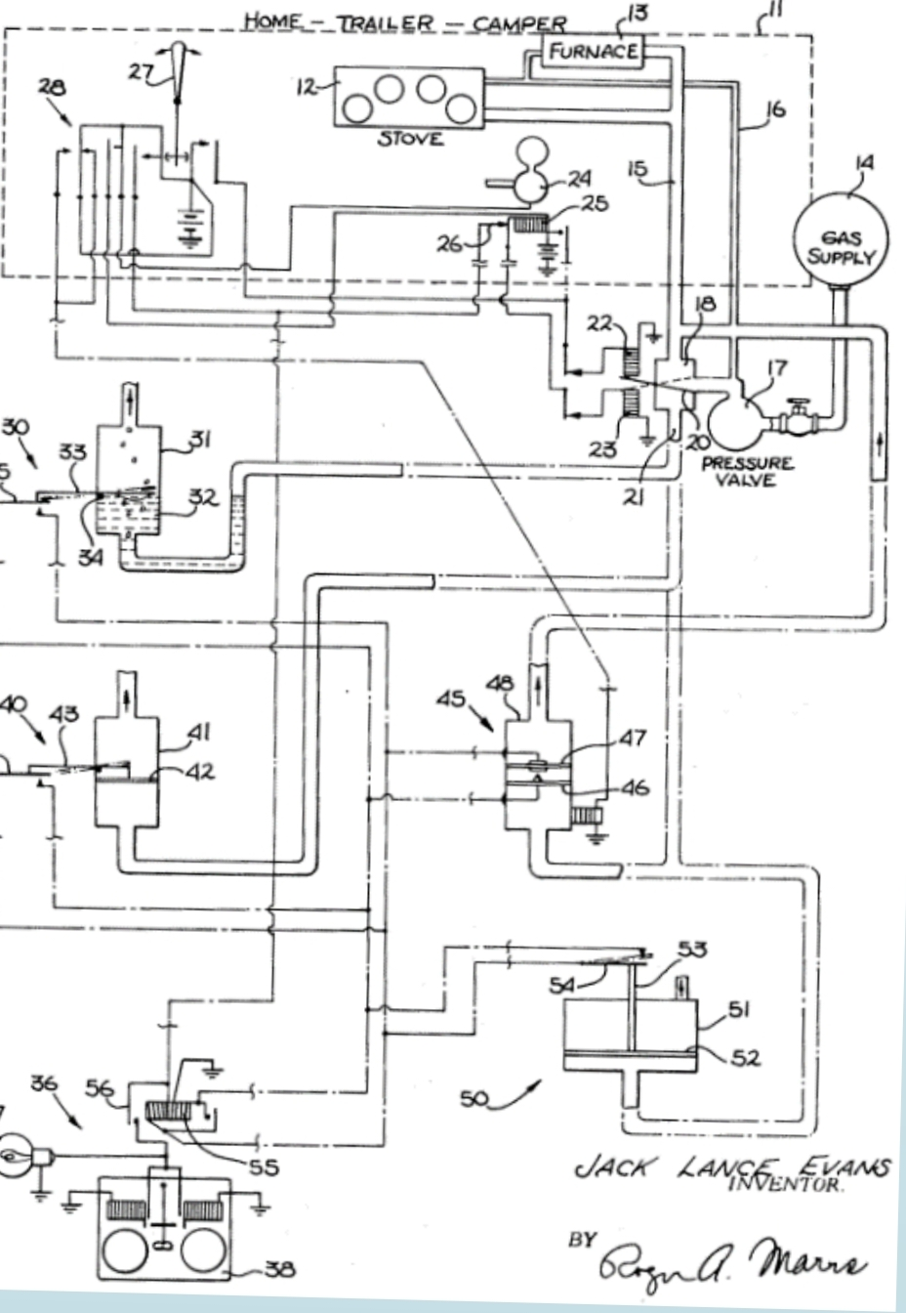**2.1 Existing Problem**

In the existing method, different gas sensing technology is used. The LPG gas leakage is detected by the semiconductor sensor. Nowadays LPG accidents occur very common. The main reason of these accidents is due to the leakage of LPG. This leakage of LPG starts when we forget to close the main regulator valve. This is the basis of these kinds of accidents. Already there are some sorts of remedial measures such as when the leakage is detected, alert messageis sent to the fire station and the owner. The other remedial measure is that when the leakage is detected, exhaust fan is switched on. The first mentioned method has the disadvantage that there is no control action taken, it needs a manual controlling which puts human into direct risk. The second method has the disadvantage that if the wiring of the exhaust fan is not proper then it will cause immediate explosion due to the flow of AC. In all these mentioned method above, there is only detection no control action is taken. Another method is also been employed which involves detecting as well as controlling of the LPG leakage. This process starts when the gas leakage occurs, the gas sensor senses it and gives an output to the micro controller. The micro controller used here is AT89C51 which converts this output into digital format and sends it to the GSM module, RF link, liquid crystal display(LCD) and to the motor driver. The GSM module sends an alert message to the user(s) and also to the fire station to alert them. The RF link is responsible for producing the alarm to alert the neighbors in case of absence of the user at home where as the LCD displays the warning message. For the controlling purpose, stepper motors driven by motor drivers are used which closes the main power supply and the cylinder’s valve to stop the flow of current and LPG gas.

**2.2 Reference**

Mahalingam, A., R. T. Naayagi, and N. E. Mastorakis.

"Design and implementation of an economic gas leakage detector." Recent Researches in Applications of Electrical and Computer Engineering (2012): 20-24.

1. Rajitha, S., and T. Swapna. "Security alert system using GSM for gas leakage." International Journal of VLSI and Embedded Systems-IJVES 3.04 (2012): 173-175.
2. Fraiwan, Luay, et al. "A wireless home safety gas leakage detection system." Biomedical Engineering (MECBME), 2011 1st Middle East Conference on. IEEE, 2011.
3. Murvay, Pal-Stefan, and Ioan Silea. "A survey on gas leak detection and localization techniques." Journal of Loss Prevention in the Process Industries 25.6 (2012): 966-973.
4. Mujawar, T. H., et al. "Development of wireless sensor network system for LPG gas leakage detection system." International Journal of Scientific & .Engineering Research 6.4 (2015): 558-563.
5. http://www.circuitstoday.com/interface-gsm-modulewith-arduino
6. [http://www.circuitstoday.com/interfacing-mq5-lpgsensor-to-arduino](http://www.circuitstoday.com/interfacing-mq5-lpg-sensor-to-arduino)

[7] L. I. Ramadhan, D. Syauqy and B. H. Prasetio, "Sistem Pendeteksi Kebocoran Gas LPG Menggunakan Metode Fuzzy yang Diimplementasikan dengan Real Time Operating System (RTOS)," J-ptiik.ub.ac.id, vol. 1, 2015

**2.3 Problem Statement**

As the whole world is developing in every way and one way includes the livelihood of the people and they are having smart technology and techniques. Alongside, the chances of accidents and damages to happen are also developing and at a very high rate but according to the recent trend, the development of Smart homes is taking place all around the world. Home automation has become very affordable and many people and even industries have started to automate daily routines like light, fans, setting the temperature, etc. And all of these include one major problem i.e. GAS LEAKAGE and it includes all the types of gases which can be disastrous and harmful for an individual. It is a major problem in induidential remises, and gas-powered vehicles. The leakage if not detected may lead to an explosion and cause severe damages to life and the environment.

**3.IDEATION & PROPOSED SOLUTION**

The proposed system includes an alerting system for the

users. The System is based on a sensor that easily detects and immediately turn off the Cylinder regulator to prevent further leakage, and an exhaust fan is

Also attached to eliminate the LPG.

**3.1 Empathy Map Canvas**

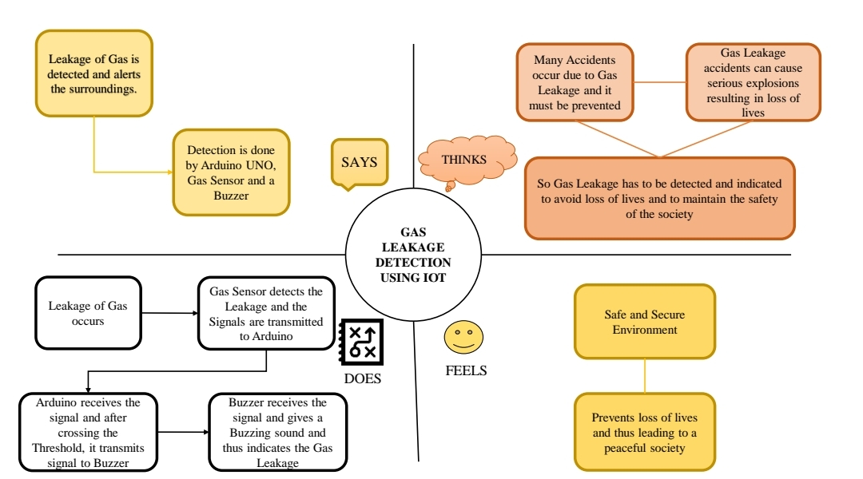

**3.2 Ideation & Brainstoming**

If the LPG sensor senses gas leak from industry, sensor

output goes to active low and it is overlooked by Arduino UNO and gas leakage is noticed.

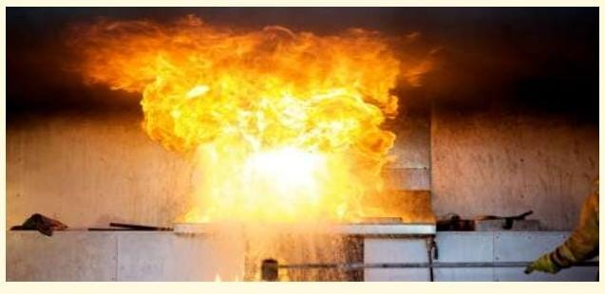

* If the gases can be leaked in industries or home, then it will detect by using gas sensor after that it gives alert sound to the people by using buzzer.



* We can propose to the system using aMQS gas detection sensor and interface if with Atmega 328 microcontroller along with an LCD display

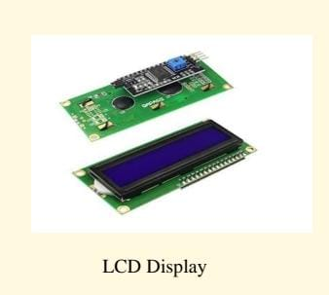

* We can read gas lekagas in industries at a time we can measure and upload it to aThingspeak cloud using FPGA and ESP8276 module

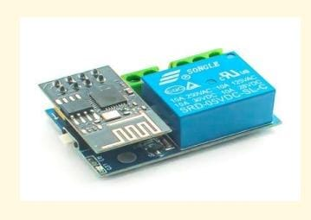

**ESP8276 module**

* **By grouping the ideas of the team members, we have proposed a solution to the problem**.

 The gas leakage monitoring system consists of Gas sensor,

Buzzer, Arduino UNO, bread board and connecting wires. The leakage gas can be detected by using the gas sensor. It gives the alert sound when recognizing the leakage.

 So that people can alert and huge exploitation can be avoided.

**3.3 Proposed Solution**

Parameter Description

1. Problem Statement

(Problem to be solved)

LPG gas can be used in the car, kitchen, and in the storage tank or service station. But, due to some reasons the LPG gas might leak from the gas cylinders, this may cause the cylinder blast, damage the building and risk of a life to the living persons in the building.

1. Idea / Solution description

The proposed system includes an alerting system for the users. The system is based on a sensor that easily detects a gas leakage. This system alerts by giving alarm sound, and immediately turn off the cylinder regulator to prevent further leakage, and an exhaust fan is also attached to eliminate the LPG.

1. Novelty / Uniqueness

In addition to an alarm, it also sends message to the user with the help of GSM Module.

1. Social Impact / Customer Satisfaction

LPG gas can be used in the car, in the storage tank or service station. But, due to some reasons the LPG gas might leak from the gas cylinders, this may cause the cylinder blast, damage the house and risk of a life to the living persons in the house. The fire ignite can be occurred due to many reasons such as an electrical short circuit, oil lamps or candles kept inside the house. Sometimes fire accidents are very small, but if proper action is not taken to control the fire, then it can spread in complete house. To overcome this problem, an LPG gas sensor is used to detect the presence of a dangerous LPG gakage in industries at a time we can measure and uplit to a ThingSpeak cloud using FPGA and ESP8276 module.

**3.4 Problem solution fit**

**1.CUSTOMER SEGMENT(S):**

It targets industry owners and workers.The main aim is to ensure the safety of workers from gas leakages that may occur in an industry

**2. JOBS-TO-BE-DONE / PROBLEMS :**

Due to certain network or connectivity issuses,the reliability of data transfer in the real time system might not withstand extremely harsh environmental conditions

**3.TRIGGERS:**

Reports in the news about the accidents due to the gas leakage and concern for the safety of networks might encourage customers to take action.

**4.EMOTIONS BEFORE / AFTER:**

When a problem arises suddenly, the user might feel confused and scared and when the problem is resolved, the user might feel relief and a sense of success.

**5.AVAILABLE SOLUTIONS:**

Sensors can be used to detect gas leakage and a buzzer can indicate the same. If there is a gas leakage, GSM module helps us to get appropriate notifications. This might be easier to implement but can be more expensive.

**6.CUSTOMER:**

To make sure that gas does not leak from anywhere, proper and regular maintenance must be done on the equipment. This might be expensive.

**7. BEHAVIOUR:**

Regular inspections can be done to find out areas in which there are gas leakages. Some detection systems can be hardwired to detect leaks. In the case of wireless systems, if there are network issues, the service provider or the helpline can be contacted.

**8.CHANNELS OF BEHAVIOUR:**

**8.1 ONLINE:**

The status of the sensor is continuously monitored and notification is received if there is any gas leakage.

**8.2 OFFLINE:**

Ensure that proper network and power is supplied to the system for it to work efficiently and prevent any physical damage that might occur to the sensor.

**9. PROBLEM ROOT CAUSE**:

Gas leakage might be caused due to usage of unreliable metal to metal seals or poor tubing during the construction of gas lines.

**10.YOUR SOLUTION:**

To develop a cost effective IOT based system that can be easily accessed and manipulated by the customers so that gas leakages are detected at the earliest possible time.

**4.REQUIREMENT ANALYSIS**

Requirement Analysis, Design & Development The main objective of our project is to ensure the LPG gas leakage and provide a signal at that time, as well as through SMS and signal to the specified mobile number. Once we are integrated with the various functions of architecture and GPS system, it is time to design the hardware and develop our concept. System Requirements The system we want to make is consisting of Arduino, GSM module, Buzzer, LCD. GSM module send the SMS to mobile number, The Arduino will control the signal as well as process the information received from the GSM. These are thefollowing hardware and software requirements, which are needed to run this project successfully.

**Hardware Requirement:**

1) Arduino UNO Microcontroller

2)16x2 LCD

3)12v dc power supply

4)5v Regulated CKT

5)Buzzer

6)LPG Gas sensor

7)GSM Module

8)GSM Sim

9)Connecting wires

10) Project base.

**Software Requirements:**

1) Arduino IDE

2) Language C++

**Flowchart:**

Flowchart a logical sequence, or structure is a graphical representation of a production process. The purpose of a flow chart of the process of working with a project or a common language or reference point is provided.

4**.1 FUNCTIONAL REQUIREMENT**

**Business Requirements:**

The said system can be deployed in homes, hotels, factory units, LPG cylinder storage areas, and so on. The main advantage of this IoT and Arduino-based application is that it can determine the leakage and send the data over to a site. It can be monitored, and preventive measures can be taken to avoid any disaster.

**User Requirements:**

The gas leakage detection system can be optimized for detecting toxic gases along with upgrading them with smoke and fire detectors to identify the presence of smoke and fire. Ensuring worker safety is important but making using of the right technology is even more vital.

**Product Requirements:**

Detecting gases is necessary regardless of your business role or individual purpose. Certain technologies at play make such IoT devices what they are, and if you want to indulge in IoT application development, you must know what they are and what purpose they can fulfil.

**4.2 NON- FUNCTIONAL REQUIREMENT**

• **Efficiency**

The product is efficient in the sense of time and space. It runs fast machine level code on a microcontroller and is able to detect and inform the user about the leakage in real-time. It is also very compact and easy to deploy.

• **Reliability**

The product is robust and able to reset itself after a leakage event and continue monitoring the environment. It is designed in such a way that once the system has been deployed it need not be maintained.

**• Portability**

The system is compact and can be set up very easily. It has good portability.

• **Usability**

The system has been designed keeping the layman in mind. It does not need any domain knowledge to operate and can be easily used by most adults

**5. PROJECT DESIGN**

**Project design phase**

**1.Customer segement(S):**

It targets industry owners and workers. The main aim is to ensure the safety of workers from gas

leakages that may occur in an industries

**2. Jobs-to-be-done / Problems:**

Due to certain network or connectivity issues, the reliability of data transfer in the real time system might be affected. The system might not withstand extremely harsh environmental conditions

**3.Tiggers:**

Reports in the news about the accidents due to gas leakage and concern for the safety of workers might encourage customers to take action.

**4.Emotions before/ After:**

When a problem arises suddenly, the user might feel confused and scared and when the problem is resolved, theuser might feel relief and a sense of success.

**5.Available Solutions:**

Sensors can be used to detect gas leakage and a buzzer can indicate the same. If there is a gas leakage, GSM module helps us to get appropriate notifications. This might be easier to implement but can be more expensive.

**6.Customer:**

To make sure that gas does not leak from anywhere, proper and regular maintenance must be done on the equipment. This might be expensive.

**7. Behaviour:**

Regular inspections can be done to find out areas in which there are gas leakages. Some detection systems can be hardwired to detect leaks. In the case of wireless systems, if there are network issues, the service provider or the helpline can be contacted.

**8.Channals of behaviour:**

**8.1 Online:**

The status of the sensor is continuously monitored and notification is received if there is any gas leakage.

**8.2 :Offline:**

Ensure that proper network and power is supplied to the system for it to work efficiently and prevent any physical damage that might occur to the sensor.

**9. Problem root cause:**

Gas leakage might be caused due to usage of unreliable metal to metal seals or poor tubing during the construction of gas lines.

**10.Yours solution:**

To develop a cost effective IOT based system that can be easily accessed and manipulated by the customers so that gas leakages are detected at the earliest possible time.

**5.1 Data Flow Diagram:**

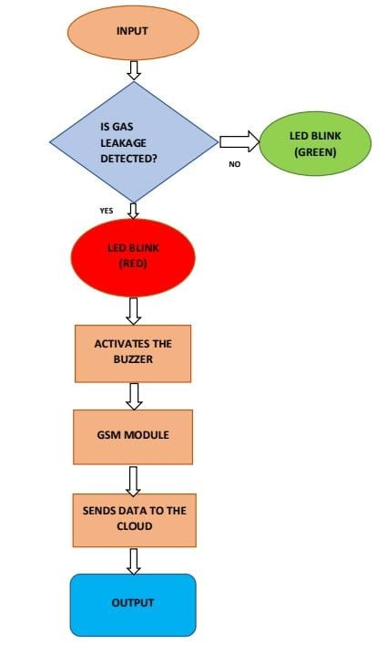

**5.2 Solution Architecture**:

Solution architecture is a complex process – with many sub-processes – that bridges the gap between business problems and technology solutions. Its goals are to:

• Find the best tech solution to solve existing business problems.

• Describe the structure,characteristics,behaviour,and other aspects of the software to project stakeholders.

• Define features,development phases,and solution requirements.

• Provide specifications according to which the solution is defined, managed, and delivered.

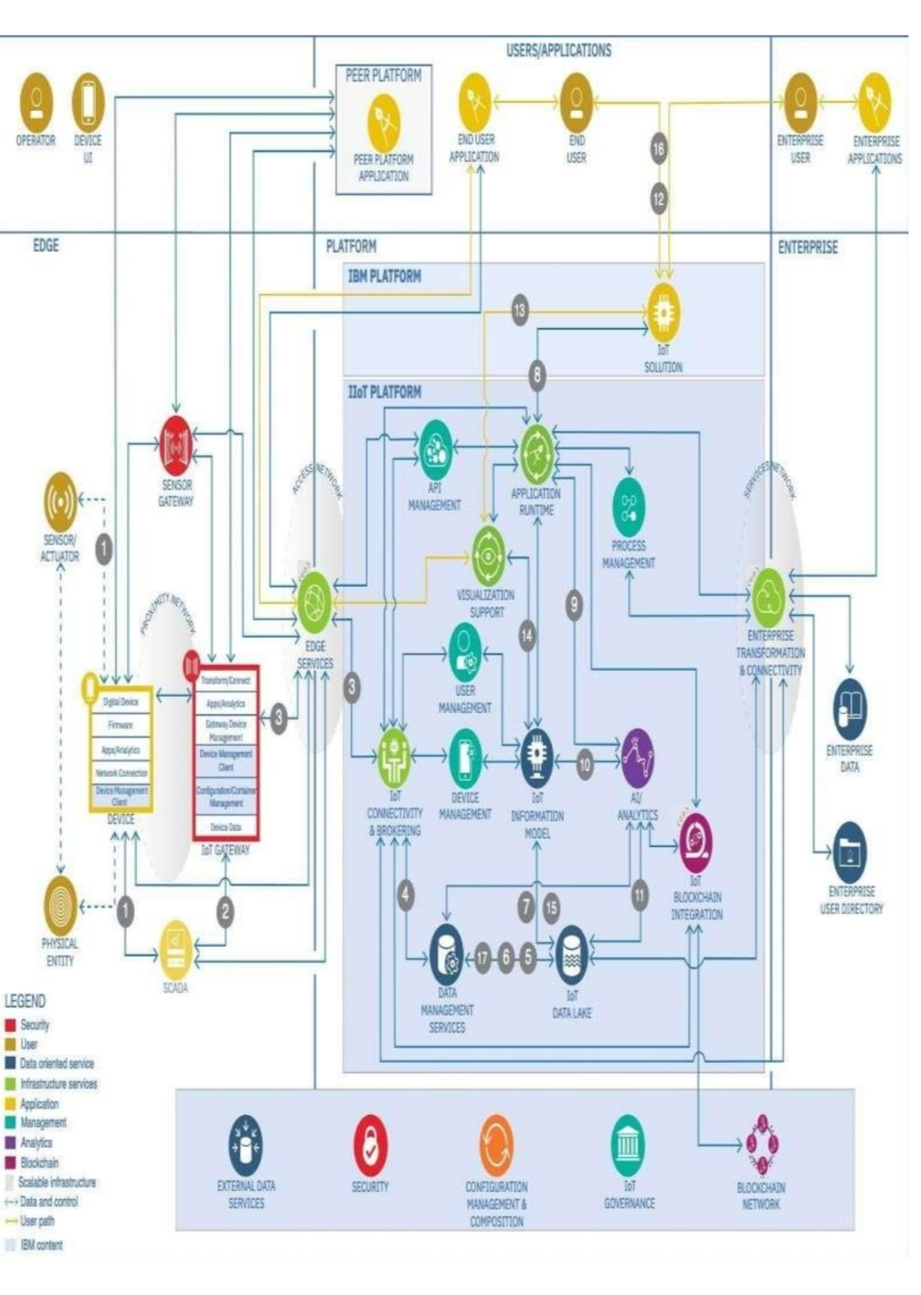

**Technical Architecture:**

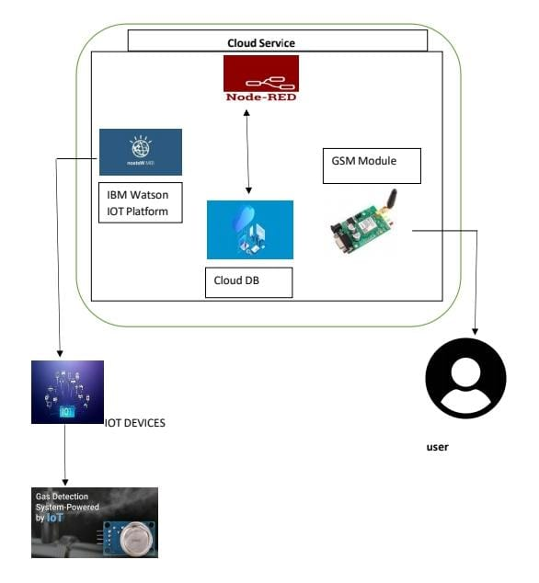

**5.3 User Stories**

The project we have designed aims to provide a reliable solution to the problem of LPG gas leakage from gas cylinders through the implementation of a network connected sensor that informs the user of a gas leakage wherever he/she may be and immediately brings the leakage of gas to his/her attention.

**6.PROJECT PLANNING &SCHEDULING**

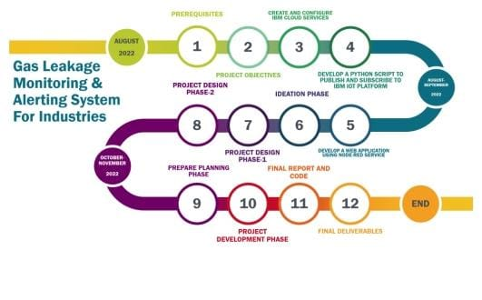

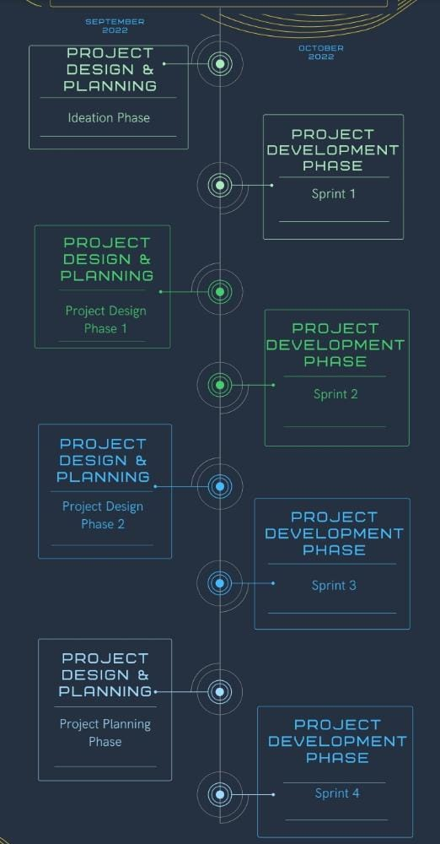

**6.1 Sprint Planning & estimation**

Task:

Sensed data is brought to Node-RED and displayed in dashboard

Steps:

1. IBM IoT node is used to gather sensor data. a. Necessary API key is provided to establish connection.

2. Using functions namely Temperature, Humidity and Gas the data is obtained independently and displayed in dashboard.

3. dashboard Nodes are used to display the sensed data to the user in a portal.

Sour code:

* Temperature: msg.payload = msg.payload.Temp; return msg;
* Humidity: msg.payload = msg.payload.Hum; return msg;
* Concentration of Gas: msg.payloamsg.payload.gas;

**OUTPUT**

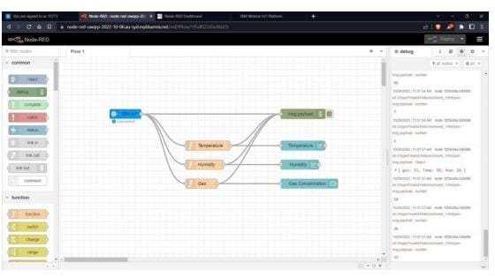

**2.Data**

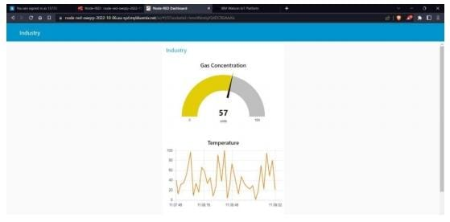

**6.2 Sprint Delivery Schedule**



**6.3 Reports from TIRA**

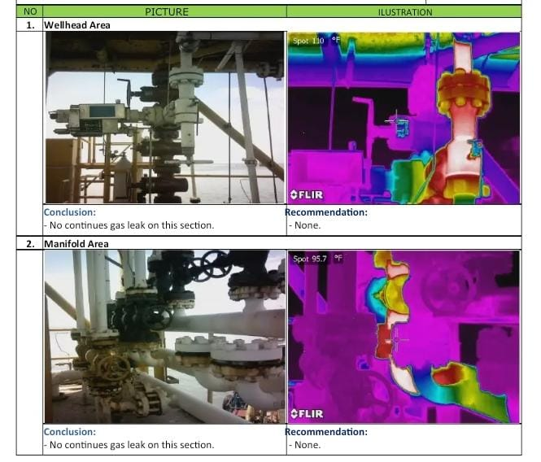

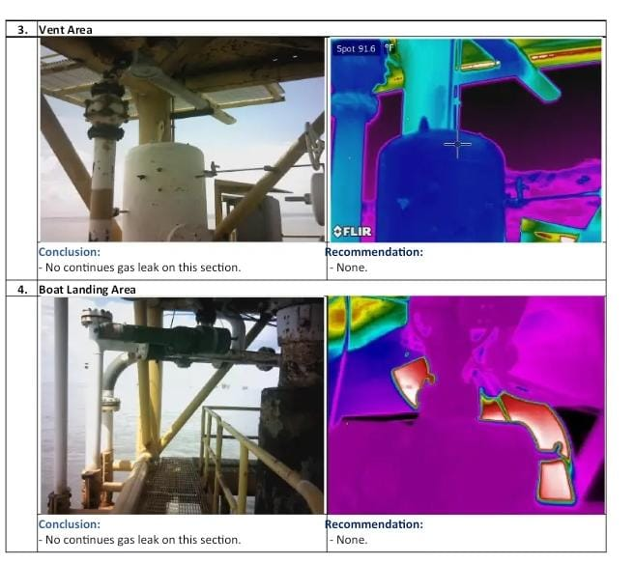

**7.1 CODING & SOLUTIONING (Explain the feature added in the project along with code )**

#include <LiquidCrystal.h>

LiquidCrystal lcd(7, 6, 5, 4, 3, 2);

#include <SoftwareSerial.h>

SoftwareSerial mySerial(9, 10);

int gasValue = A0; // smoke / gas sensor connected with analog pin A1 of the arduino / mega.

int data = 0;

void setup()

{

randomSeed(analogRead(0));

mySerial.begin(9600); // Setting the baud rate of GSM Module

Serial.begin(9600); // Setting the baud rate of Serial Monitor (Arduino)

lcd.begin(16,2);

pinMode(gasValue, INPUT);

lcd.print (" Gas Leakage ");

lcd.setCursor(0,1);

lcd.print (" Detector Alarm ");

delay(3000);

lcd.clear();

}

void loop()

{

data = analogRead(gasValue);

Serial.print("Gas Level: ");

Serial.println(data);

lcd.print ("Gas Scan is ON");

lcd.setCursor(0,1);

lcd.print("Gas Level: ");

lcd.print(data);

delay(1000);

if ( data > 500) //

{

SendMessage();

Serial.print("Gas detect alarm");

lcd.clear();

lcd.setCursor(0,0);

lcd.print("Gas Level Exceed");

lcd.setCursor(0,1);

lcd.print("SMS Sent");

delay(1000);

}

else

{

Serial.print("Gas Level Low");

lcd.clear();

lcd.setCursor(0,0);

lcd.print("Gas Level Normal");

delay(1000);

}

lcd.clear();

}

void SendMessage()

{

Serial.println("I am in send");

mySerial.println("AT+CMGF=1"); //Sets the GSM Module in Text Mode

delay(1000); // Delay of 1000 milli seconds or 1 second

mySerial.println("AT+CMGS=\"+91900xxxxxxx\"\r"); // Replace x with mobile number

delay(1000);

mySerial.println("Excess Gas Detected. Open Windows");// The SMS text you want to send

delay(100);

mySerial.println((char)26);// ASCII code of CTRL+Z

delay(1000);

**7.1 Feature 1**

* Support up to 552 keypads
* One full function UART port, and can be configured to two independent serial ports
* One USB port can be used as debugging and firmware upgrading.
* Audio channel which include a microphone input and a receiver output .
* Programmable general – purpose input and output
* One SIM card interface
* Support Bluetooth function
* Support one PWM
* Power supply 3.4v ~ 4.4v
* Typical power consumption in sleep mode 1.2mA
* Frequency bands GPRSmulti – slot class 12
* Support SIM card : 1.8V,3V
* Serial port : can be used for AT commands for data stream
* USB Port : can be used as debugging and firmware .

**7.2 Feature 2**

* High Sensitivity
* High sensitivity to ammonia ,sulfie, and benze
* Stable and long life
* Detection range : 10 – 300 ppm NH3, 10 – 1000 ppm Benzene ,10 – 300 Alcohol
* Heater voltage : 5.0V
* Dimensions :

18mm diameter,17mm high excluding pins, pins – 6mm high

* Long life and low cost

**7.3 Data base scheme (if applicable )**

Aim: To create a database in Cloudant DB to store location data. Steps followed:

● Logged in to IBM Cloud account.

● Navigated to `./resources`.

● Clicked on the “Create Resource +” button.

● Searched for “Cloudant”.

● Chose the “Lite Version” and clicked on “Create”.

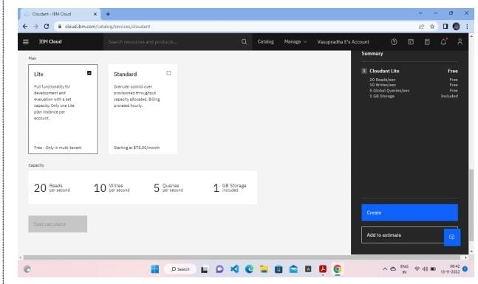

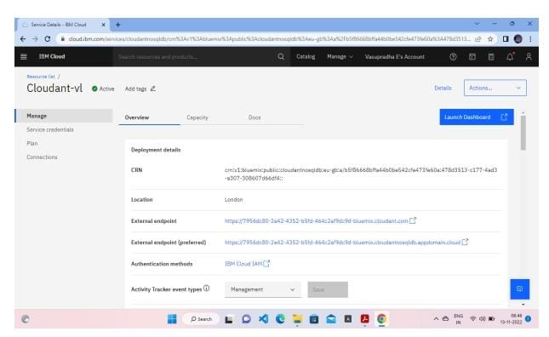

* Clicked on launch dashboard

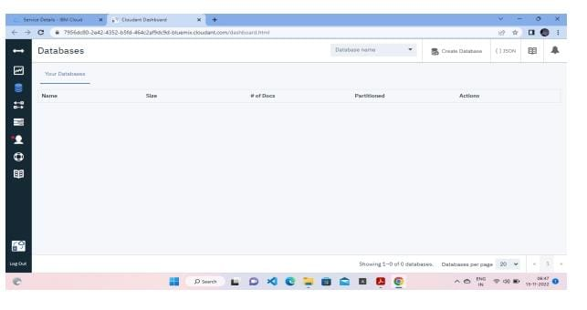

* Clicked on “Create Database :,Entered “meowman” as the database name and the “Non – partitioned” option
* 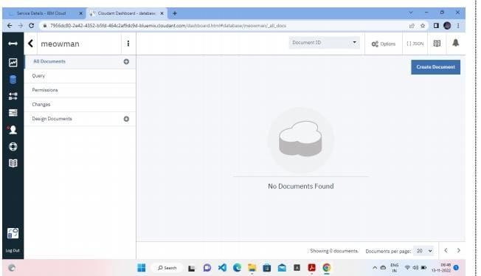The database “meowman” was created successfully

**RESULT**

A database to store the location data was created successfully on cloudant DB.

**8.** **TESTING**

In this system and tool to enter the cellphone number for sending SMS messages, the author makes it by entering the destination number directly on the syntax code created in the Arduino IDE. In other words, the destination number cannot be replaced automatically except by directly replacing the code syntax that has been created (loading code). In addition, the cellphone number that is the destination for sending SMS messages in the event of an LPG gas leak can only be entered by one cellphone number. In other words, the system and this tool will send an SMS message that the LPG gas leak notification is limited to only one destination mobile number.

**8.1 Test Cases**

In testing the sensor is done in two stages, namely, the testing phase in the room (closed) and the outdoor testing stage (open), to see the performance of the gas sensor MQ-2 itself. Given that the MQ2 gas sensor is the main indicator of the work of this system and tool. The results of the testing of the MQ-2 gas sensor are as follows.

1. **Indoor testing**

|  |  |  |  |
| --- | --- | --- | --- |
| S.No | Distance | Gas level detected | Percentage of gas detected |
| 1 | 1. 1,5 meters | 200 - 457ppm | 2 – 4% |
| 2 | 0.5 – meters | 237 – 1027ppm | 2 – 10 % |
| 3 | 1. 0,5meters | 459 – 7102ppm | 4 – 70 % |

1. **Testing in an open room)**

The results of this test are that the sensor is unable to detect the presence of leaky gas levels unless the gas leak point is attached to the MQ-2 gas sensor, the sensor will detect the presence of gas with a level of 200-4000 ppm, or in percentage 2 - 40%.

**8.2 User Acceptance Testing**

**Unit** **Testing**

Unit tests intended in the module model are accomplished on the code during this validation phase. Unit testing is the assessment of code level and it helps eradicate bugs at an early stage, though all deficient cannot be exposed by unit testing.

**Integration** **Testing**

Integration testing is connected with the architectural design stage. Integration tests are accomplished to test the existence and transmission of the internal components within the system.

The figure shows the Circuit Diagram of our proposed project “Gas Leakage Monitoring and Alerting System for industries ”.

**System Testing**

System testing is openly related to the system design phase. System tests inspection the entire system ability and the transmission of the system under improvement with external systems. The issue can be uncovered during test execution by using the software’s and hardware’s compatibility.

**9. RESULTS**

After conducting research and analyzing to produce, make and test the cases submitted in this final project, the results of this case study on the system and this tool can help humans to increase proven gas reserves and provide assistance to their owners that they have gas leak in the form of an alarm is also sent a message in the form of an SMS to the owner. While the circuit and cabling of this l will open a box that will be displayed as follows. This tool is equipped with as a display to display the work process of the tool itself. Then the buzzer is active as an alarm marker in the event of a gas leak. And also equipped with the gas sensor itself, in this case, the MQ-2 gas sensor. This tool is also equipped with 3 complete LED lights - also a green power light that indicates the device is on, a yellow LED that indicates the active device is detecting the existing LPG gas levels, also a red LED that indicates the danger that gas leak LPG. Then this tool is also equipped with a GSM module, SIM800L, which functions to send SMS messages in the event of an LPG gas leak. The form and format of sending SMS messages from this tool can be seen in Figure

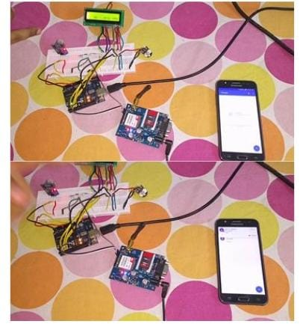

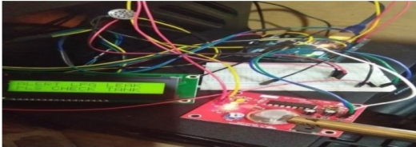

**9.1 Performance Metrics**

The important sensors used are temperature sensor, gas sensor and the load cell. During the startup the arduino checks the temperature sensor for any fire accidents. If there is indeed fire, then the fire brigade is intimated.

Fig.2. Circuit Diagram

This is followed by the gas sensor that detects any

leakage, if there is a leak then a exhaust fan is switched on

till the gas percentage falls below hazardous levels Finally

if all cases prove to be false then the load cell checks the

cylinder weight to enable auto booking if the weight is 1/3

of the cylinder weight.

The simulation results are checked for seven cases, They

are as follows

**Case 1:**

Load Cell:In this case the working of a load cell is

demonstrated. When the weight of the cyclinder is half filled it sends message to the Gas station stating that the gas is to be booked.

**10.ADVANTAGES & DISADVANTAGES**

**Advantages**

• Because of the very narrow 0.3 nm line width of the laser emission, there is no

interference from other gases.

• Response times are in the order 1 second. This allow for fine

resolution/control when making process measurements.

• The intense laser light concentrated at the absorption wavelength enables

path lengths up to 1 km to be measured.

• An average measurement is taken over the total path so that a narrow

plume of gas has less chance of escaping detection.

• The range of measurement can be up to 4 orders of magnitude, enabling

concentrations of 0.1 ppm to 1000 ppm to be measured.

• Because of the internal reference cell, the system is self calibrating.

• There is no ‘poisoning’ or degradation of the instrument with long term

exposure to a gas.

• Can easily be conformed to be ‘Intrinsically Safe’.

• Low maintenance and low operating costs.

• Reliable technology.

**Disadvantages:**

• Only one gas can be measured with each instrument.

• When heavy dust, steam or fog blocks the laser beam, the system will not

be able to take measurements. This is also the case when a person or vehicle blocks the path.

**11.CONCLUSION**

After all the data had been gathered, analyzed and processed, the proponents arrived at the succeeding conclusion. Therefore, the researchers concluded that the “GAS Leakage Monitoring and Alerting System for Industries” will help a lot in terms of preventing any danger caused by gas leakage and useful as part of safety to avoid the gas leak that can cause harmful result. It will also improve the safety of all users of Liquefied Petroleum Gas.

**12. FUTURE SCOPE**

The future scope of this project had been performed in order to achieve the objectives of this project. Design and build a prototype of an LPG leakage detector controlled by Arduino Uno using MQ-2 gas sensor to detect the presence of gas leakage and DHT-11 temperature sensor. To give the real time response, Espresso lite V2.0 was used as Wi-Fi module and Blynk act as software that use to display all the reading.

This system can be implemented in residential area, small industries and restaurant. Besides that, this system also exposes to the community about the important of the LPG leakage detector to be used because it can help to avoid any dangers of gas leakage that not only can give effect to the user but to the other person too.

**13.APPENDIX**

|  |  |
| --- | --- |
| **COMPONENTS** | **COST (in rupees)** |
| Arduino Uno | Rs 515 |
| MQ6gas sensor | Rs 300 |
| 16*2 LCD display | Rs 780 |
| DHT11 Temperature sensor | Rs 156 |
| Buzzer (piezoelectric) | Rs 160 |
| DOT PCB | Rs 270 |
| Wires(connecting & jumper) | Rs 120 |
| Potentiometer | Rs 10 |

**Source Code**

#include <LiquidCrystal.h>

LiquidCrystal lcd(5,6,8,9,10,11);

int redled = 2;

int greenled = 3;

int buzzer = 4;

int sensor = A0;

int sensorThresh = 400;

void setup()

{

pinMode(redled, OUTPUT);

pinMode(greenled,OUTPUT);

pinMode(buzzer,OUTPUT);

pinMode(sensor,INPUT);

Serial.begin(9600);

lcd.begin(16,2);

}

void loop()

{

int analogValue = analogRead(sensor);

Serial.print(analogValue);

if(analogValue>sensorThresh)

[10:51 AM, 11/19/2022] Thanga Pulla. 🌹: {

digitalWrite(redled,HIGH);

digitalWrite(greenled,LOW);

tone(buzzer,1000,10000);

lcd.clear();

lcd.setCursor(0,1);

lcd.print("ALERT");

delay(1000);

lcd.clear();

lcd.setCursor(0,1);

lcd.print("EVACUATE");

delay(1000);

}

else

{

digitalWrite(greenled,HIGH);

digitalWrite(redled,LOW);

noTone(buzzer);

lcd.clear();

lcd.setCursor(0,0);

lcd.print("SAFE");

delay(1000);

lcd.clear();

lcd.setCursor(0,1);

lcd.print("ALL CLEAR");

delay(1000);

}

}

**Github & Project Demo Link**

**IBM-Project-51410-1660979129**

**https://github.com/**